Summary

**Today: centralized production of energy** **1**

**Problems** **2**

**Tomorrow: decentralized energy grid** **3**

Our solution 3

We solved these problems: 4

**Go to market** **4**

**Potentials clients** **4**

**Our solution in details** **5**

**What we have implemented during hackathon** **6**

**Infrastructures, technology** **6**

**Summary** **6**

**Annexes** **6**

# Today: centralized production of energy

description of current situation, how energy is produced: centralized producers

“The **production** of **energy** in the EU is spread across a range of different **energy** sources: solid fuels (largely coal), natural gas, crude oil, nuclear **energy** and renewable **energy** (such as hydro, wind and solar **energy**).” [Source](https://ec.europa.eu/eurostat/cache/infographs/energy/bloc-2.html)

Today energy is produced by 29% by renewable energies, by nuclear energy with 26%, by coal and lignite with 21%, by natural and derived gas with 20%. [Source](https://www.eea.europa.eu/data-and-maps/indicators/overview-of-the-electricity-production-2/assessment-4)

The energy produced is then injected in a centralized grid. Thus consumers have to take power from the centralized grid.

Prosumers are retributed by a global entity and paid in fiat money or get an energy credit.

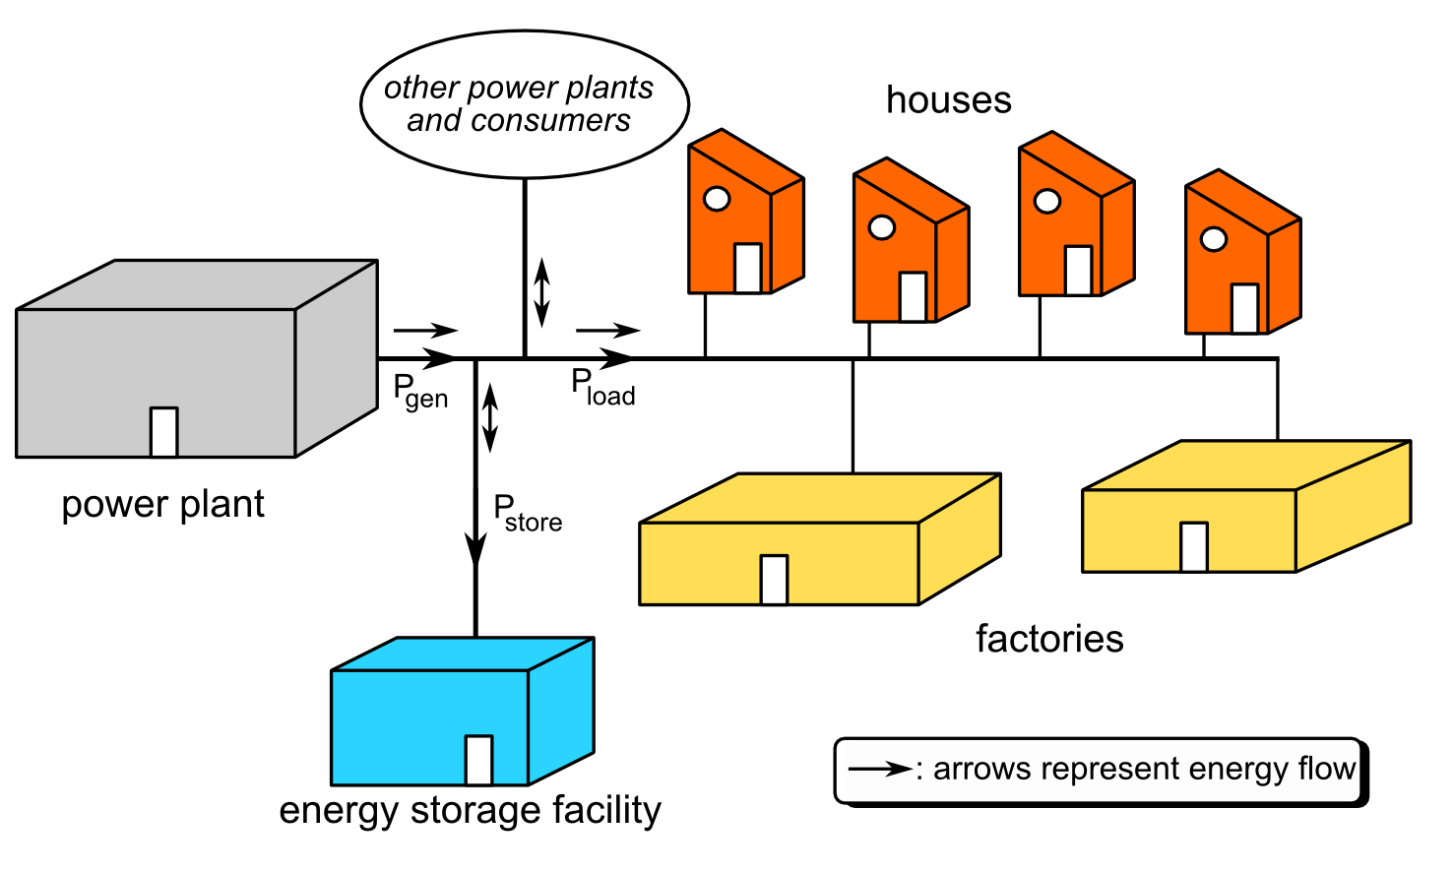

## Problems

list 5 problems at least and what they cost

|  |  |  |  |  |
| --- | --- | --- | --- | --- |
| problem 1 | problem 2 | problem 3 | problem 4 | problem 5 |
| power producers, transmission system operators, distribution system operators and suppliers transact on various levels **but do not link consumer directly** except for billing | prosumer (person producing and consuming energy) are not connected | no way to favorise one energy provider over another. Only solar and never nuclear power. | no guarantee that green power bought is really green and not completed by nuclear at peak period | Lower transaction costs due to the elimination of the intermediaries |
|  |  |  |  | At least 4 intermediaries between the producer and the end user |

# Tomorrow: decentralized energy grid

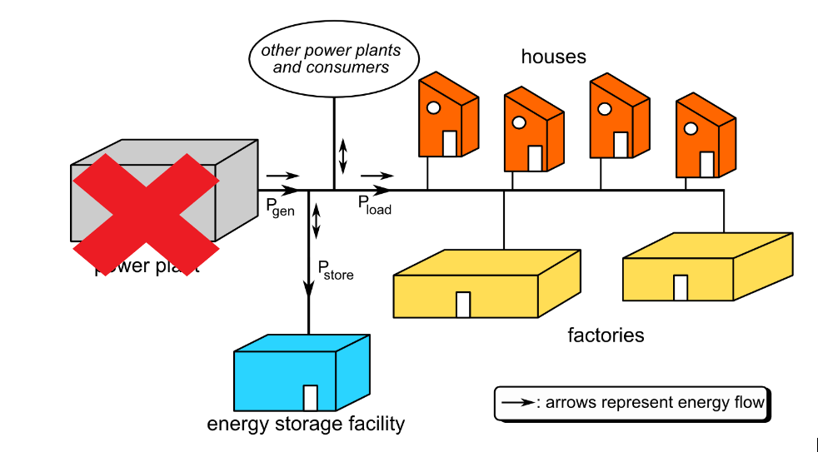

## Our solution

Bloclchain enables households that not only consume but also produce energy, to buy and sell energy directly, with a high degree of autonomy and in a trustless maneer.

Our solution **cryptometertm** powered by blockchain provides

* metering: how much energy was produced -> see our dashboard mockup
* billing: how much token will be received, or how much credit the producer has
* clearing processes: Clearing is the process of reconciling purchases and sales of various options, futures, or securities, as well as the direct transfer of funds from one financial institution to another.
* documentation of ownership, the state of assets (asset management),
* guarantees of origin: how the energy was produced
* renewable energy certificates for consumers that prefer to favorise green produced energy

|  |  |  |  |  |
| --- | --- | --- | --- | --- |
| solution to 1 | solution to 2 | solution to 3 | solution 4 | solution 5 |
| consumers and producers are directly linked in a trustless way | prosumers can now sell the energy they generate directly to their neighbours. | documentation of ownership allow consumers to know the origin of energy | proof of origin or label can be created | a peer to peer communication that is made between consumers and producers |

## We solved these problems:

And how much? some figures …..

# Go to market

Which country first and why?

Germany solar installed base… some figures so you justify why first germany for example

We are going to target Germany first because it is the most equipped country at the moment. We are then going to focus Spain and France that are the second and the third. The end goal is to provide our solution to all Europe.

How our solution can be monetized

## Potentials clients

The targeted people are the owners of following energy producing devices

|  |  |  |  |
| --- | --- | --- | --- |
| type | individuals | small producers | big producers |
| winds |  |  |  |
| solar |  |  |  |
| biomasse |  |  |  |
| Waterplant |  |  |  |
| solid fuels (coal) |  |  |  |

# Our solution in details

* Ethereum blockchain
* 4 actor
  + BOB produce with solar energy
  + ALICE want to consume only solar energy
  + JOE produce energy from Coal
* Solar panel simulated by a script that simulate a producer of solar panel energy: Create a transaction and certify that 5kw has been produced by BOB, this would be normally done by a secured **cryptometertm** that has to be installed at BOB’s place.
* Alice is a consumer, that would like to favorise only solar panel energy production. She query the smart contract of our **cryptometertm** platform with these parameter 1kw / solar and pay directly BOB proportionally to the amount requested.
* We assume 1 Ether = 1kwh (in production a cryptocurrency that is based on other currencies)

Blockchain, solar panel networks connected to the swiss grid electricity with power meters in order to check how much power is injected and how much power is taken from the swiss grid.

# What we have implemented during hackathon

During the 24h of the hackathon, we implemented a mockup of the frontend website and a basic smart contract to create, assign and trade token (ETH).

# Infrastructures, technology

To create a live mockup, we needed to implement a development server (we used XAMPP) and we implemented some library for the style and animations. We also implemented a development environment to create smart contract.

# Summary

Our project is a solution for all households with a way to generate electricity. Currently, when households with a solar panel does not use the energy produced by the solar panel, the energy is sold back to the electricity grid. The selling price of energy to the grid is a problem because it is much cheaper than the purchase price. Our project is a solution for the user to store his surplus energy. The energy will be stored in the form of an energy loan. The energy that a household has lent can be reused by the same household.

# Annexes

140 application of blockchain in energy sector

<https://www.sciencedirect.com/science/article/pii/S1364032118307184>

<https://www.pwc.com/gx/en/industries/assets/pwc-blockchain-opportunity-for-energy-producers-and-consumers.pdf>

It’s a centralized system where the power plant (Energy Provider) have absolute control over the grid.